Topic :- Threats and Vulnerabilities in MANET Environments:

Types of Attacks, Vulnerabilities

Abstract:-

Mobile Ad hoc Networks (MANETs) are decentralized wireless networks characterized by dynamic topologies, where nodes can move freely and spontaneously form connections. While this flexibility enables robust communication in various applications, it also exposes the network to numerous threats and vulnerabilities. This paper provides a comprehensive overview of the types of attacks targeting MANETs, including passive and active attacks such as eavesdropping, Denial of Service (DoS), and routing attacks like black hole and Sybil attacks. Additionally, we explore the inherent vulnerabilities within MANETs, such as limited resources, the lack of centralized control, and the open medium of communication. We also discuss potential countermeasures, including authentication protocols, encryption methods, and secure routing protocols aimed at enhancing network security. By highlighting the significance of addressing these challenges, this paper emphasizes the need for ongoing research to develop effective security solutions in MANET environments.

Intro:-

MANET is a type of network that does not require fixed infrastructure, like base stations, to communicate and operate. In MANETs, the wireless devices or nodes communicate with each other without being dependent on any centralized management system.

Within the MANET, the nodes themselves oversee proactively finding new nodes with whom to connect. Because of the range limitations of wireless networking interfaces, it may be necessary for one wireless mobile node to use other hosts to send a packet to its intended destination.

Each wireless mobile node can function as a host and as a router, routing packets to and from other wireless mobile nodes in the network that are not necessarily within direct transmission range of one another.

The highlights of MANET networks are that they are peer-to-peer, self-forming, and self-healing in nature. MANET network primarily uses radio frequencies between 30MHz to 5GHz. MANET network applications can be helpful in road safety, home sensors and rescue operations.

Features of MANET:-

1. Uses rapidly changing topologies

2. Restricted bandwidth links with fluctuating capacities

3. Self-monitored behavior independent of the environment

4. Operation with a Limited Energy Budget

5. Prone to security threats

6. Minimum human intervention

THREATS INVOLVED IN MANET:

The following are some of the more general challenges that are involved with mobile ad hoc network deployment.

Wireless Links: Wireless networks often have smaller bandwidths than their wired counterparts. Attackers may exploit this limitation by wasting network capacity with relative ease, interfering with regular communication between nodes.

Network Distribution: Like peer-to-peer (P2P) networks, distributed computing implies the absence of a centralized server to manage the clients' state.

Rapid Topology: Consequently, the network's topology might alter regularly. Because the nodes are movable, the network can self-organize. It is difficult to distinguish between normal network behavior and abnormal or malicious behavior in this dynamic context.

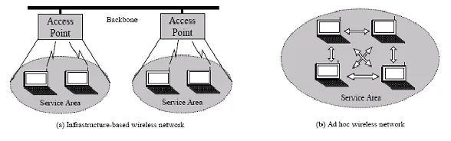

Basic MANET Architecture:-

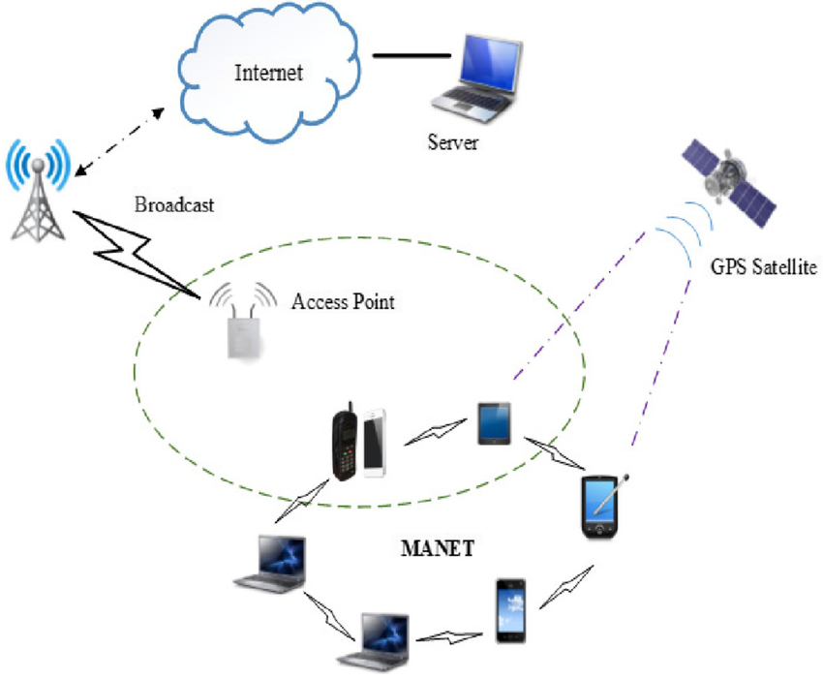

* Nodes
* Communications Links
* Routing Protocols
* Network Layer
* Transport Layer
* Application Layer
* Control Messages.

Types Of Attack and Variabilities in MANET: -

**1. Passive Attacks**:

* **Eavesdropping**: Unauthorized interception of data being transmitted over the network.
* **Traffic Analysis**: Monitoring the flow of data to deduce sensitive information without altering it.

**2.Active Attacks**:

* **Denial of Service (DoS)**: Attacks that disrupt the availability of the network, making it unusable for legitimate users.
* **Node Misbehavior**: A node that fails to behave as expected, such as refusing to forward packets.
* **Sybil Attack**: A single malicious node presents itself as multiple nodes, influencing network operations and trust.

3. **Routing Attacks**:

* **Route Spoofing**: Sending false routing information to manipulate network routes.
* **Link Layer Attacks**: Manipulating the link layer to disrupt communication.

4. **Physical Attacks**:

* **Node Capture**: Physical tampering with nodes can compromise the network by allowing attackers to gain control over a node.

### Vulnerabilities

1. **Dynamic Topology**:
   1. The constant movement of nodes can lead to instability in routes, making the network vulnerable to disruptions.
2. **Limited Resources**:
   1. Nodes often have constraints in battery life, processing power, and memory, limiting their ability to perform security tasks.
3. **Open Communication Medium**:
   1. The wireless nature of communication allows attackers to easily intercept data transmissions.

Challenge in MANET Environment:-

### **Dynamic Topology**

* The frequent movement of nodes can lead to constant changes in the network structure, making it difficult to maintain stable connections and efficient routing.

### **2. Limited Resources**

* Nodes often have constraints in battery life, processing power, and memory, which can limit their ability to handle complex tasks and security measures.

### **3. Security Vulnerabilities**

* The lack of centralized control and the open wireless medium expose MANETs to various attacks, including eavesdropping, Denial of Service (DoS), and routing attacks.

### **4. Scalability**

* As the number of nodes increases, managing the network efficiently becomes more challenging. This includes maintaining routing tables and managing bandwidth.

### **5. Routing Protocol Limitations**

* Many routing protocols used in MANETs are designed for specific conditions and may not perform well under varying network scenarios, such as high mobility or dense environments.

### **6. Network Partitioning**

* Nodes may become isolated from each other due to mobility or obstacles, leading to network partitions that disrupt communication.

### **7. Quality of Service (QoS)**

* Ensuring consistent QoS, such as bandwidth, latency, and reliability, can be difficult due to the dynamic nature of the network and varying node capabilities.

Example: Disaster Response Scenarios: -

#### **Context**

In disaster recovery operations, such as during natural disasters (earthquakes, floods, etc.), traditional communication infrastructure may be damaged or non-functional. First responders often rely on MANETs to establish communication quickly and effectively in these chaotic environments.

#### **Scenario**

Imagine a team of rescue workers deployed to a disaster area where conventional communication networks are down. They set up a MANET using their mobile devices, which communicate directly to share vital information, such as the locations of survivors, resource needs, and operational updates.

#### **Vulnerabilities in Action**

1. **Dynamic Topology**: As rescue workers move through the area, the network topology changes frequently, leading to potential communication gaps.
2. **Eavesdropping**: An attacker positioned nearby can intercept communications, gaining sensitive information about the rescue operations, such as planned routes and resource allocations.
3. **Denial of Service (DoS)**: A malicious actor might launch a DoS attack by flooding the network with bogus messages, disrupting the communication among rescue teams at a critical moment.
4. **Black Hole Attack**: An infiltrator could disguise themselves as a legitimate node, advertise a false route to the rescue workers, and then drop messages, preventing crucial information from reaching its destination.
5. **Physical Attacks**: If an attacker manages to capture one of the mobile devices, they could extract sensitive information or gain control over the network, compromising the entire rescue operation.

#### **Mitigation Strategies**

To counter these threats, the rescue team can implement several measures:

* **Encryption**: Ensuring all communications are encrypted to protect against eavesdropping.
* **Authentication Protocols**: Implementing strong authentication methods to verify the identity of nodes before allowing them to join the network.
* **Intrusion Detection Systems**: Employing IDS to monitor network traffic for suspicious activities and react promptly to potential threats.

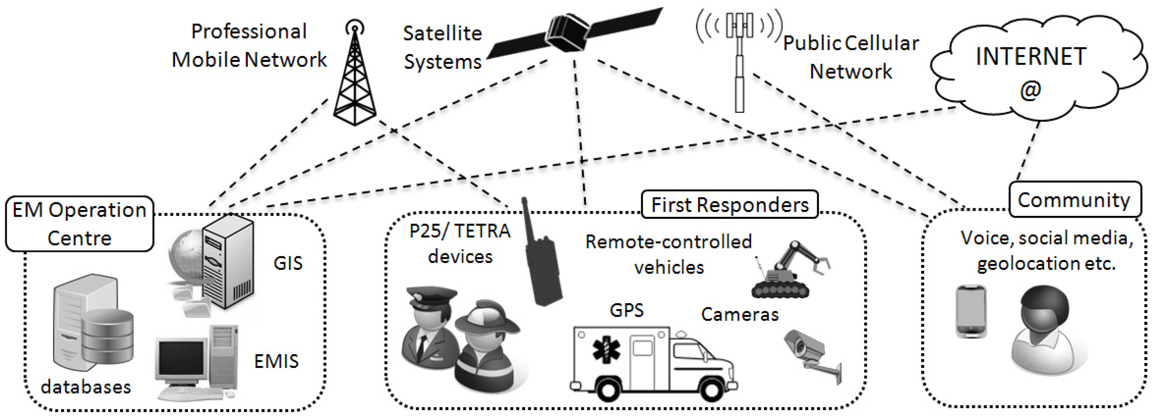

### **Conclusion**

Mobile Ad hoc Networks (MANETs) are important for communication, especially in situations where traditional networks aren't available, like during natural disasters. However, these networks face many risks and weaknesses that can disrupt their use. This paper discussed various types of attacks, such as eavesdropping and Denial of Service, and highlighted vulnerabilities like the constantly changing network layout and limited resources.

The example of rescue operations shows how crucial it is to address these security challenges. First responders depend on MANETs to communicate quickly and effectively when lives are at stake.

To keep these networks secure, we need to use strong security measures, including encryption and authentication. Ongoing research is necessary to improve these solutions as new threats emerge.